**RESALE VALUE PREDICTION USING WATSON STUDIO AI:**

1INTRODUCTION

1.1. Overview

1.2 Purpose

2LITERATURE SURVEY

2.1 Existing problem

2.2 Proposed solution

3THEORITICAL ANALYSIS

3.1 Block diagram

3.2 Hardware / Software designing

4 EXPERIMENTAL INVESTIGATIONS

5 FLOWCHART

6 RESULT

7 ADVANTAGES & DISADVANTAGES

8 APPLICATIONS

9 CONCLUSION

10FUTURE SCOPE

`11BIBILOGRAPHY

APPENDIX

A. Source code

**1.INTRODUCTION:**

**Problem statement:** Resale value of car prediction using regression model.

* **Overview:**

Here a model is designed for predictive analysis using IBM Watson studio.This model helps various dealers to predict the resale value of a car that comes to them. This can effectively benefit both the buyer and the seller by giving the cost prediction based on certain factors and information.

* **Purpose:**

Due to the difficult situations in the present economic conditions the resale and second hand usage of cars is likely to increase. So there is a need of the trained model that predicts the cost without conflicts based on certain important features and factors.

**2.LITERATURE SURVEY:**

* **Existing Problem:**

It is common that there is a scope of various conflicts when it comes to buying and selling the second hand cars to determine the salvage value. As the present economic situations are in a problematic state there is more scope for the resale business to grow. At this point of time the buyers and sellers need a machine learning trained model that predicts the salvage value.

* **Proposed Solution:**

The aim of this project is to provide a machine learning model that is developed on IBM Watson studio that can predict the salvage value of the car based on the factors such as name and brand of the car, who is the seller, vehicle type, year of registration, gearbox type, how many kilometres did it travel etc.

**3.THEORETICAL ANALYSIS:**

* **Block diagram;**

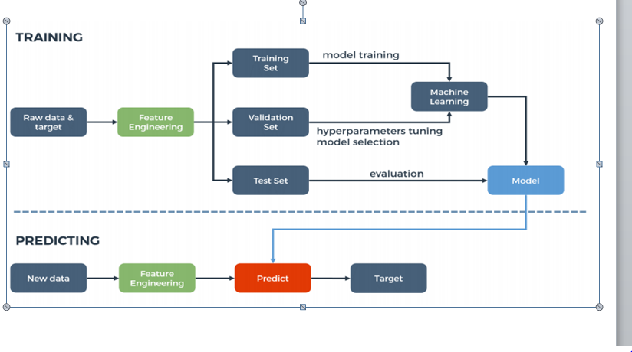

* **Hardware Software designing:**

Python vision based computer and knowledge about the various algorithms in machine learning that can be used to train the model. How to use the IBM Watson Studio inorder to deploy the project.

**4. EXPERIMENTAL INVESTIGATIONS:**

* **Step 1:** Collect the required dataset. For this I collected the dataset from kaggle.

<https://www.kaggle.com/orgesleka/used-cars-database>

* **Step 2:** To build the model on the IBM Watson Studio platform use the auto AI that helps in creation of predictive machine learning model.
  1. For this we need to create an account on the IBM Watson studio.
  2. Using the add project option we need to choose auto AI.

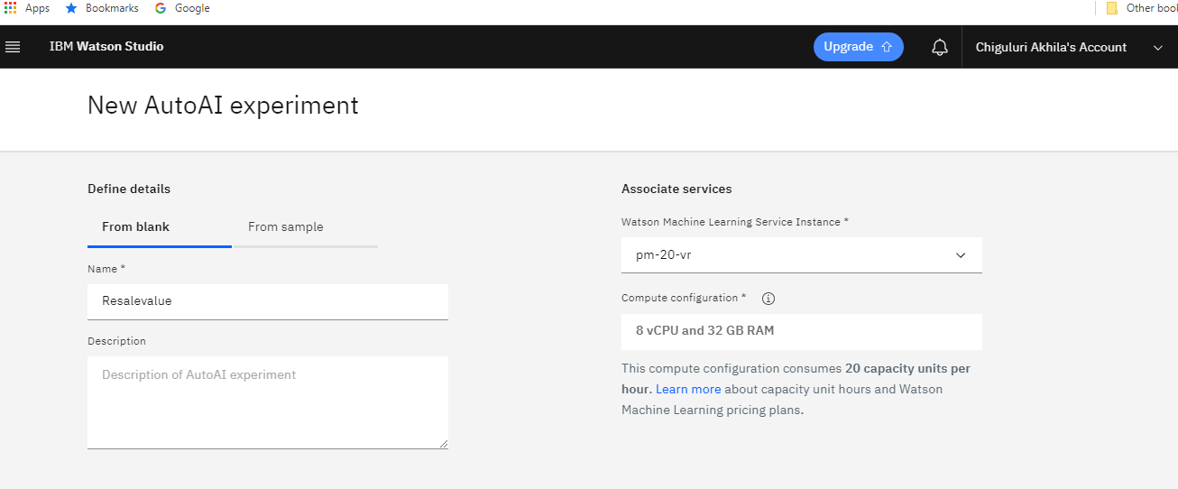

* 1. Then we need to upload the dataset at the data assets.

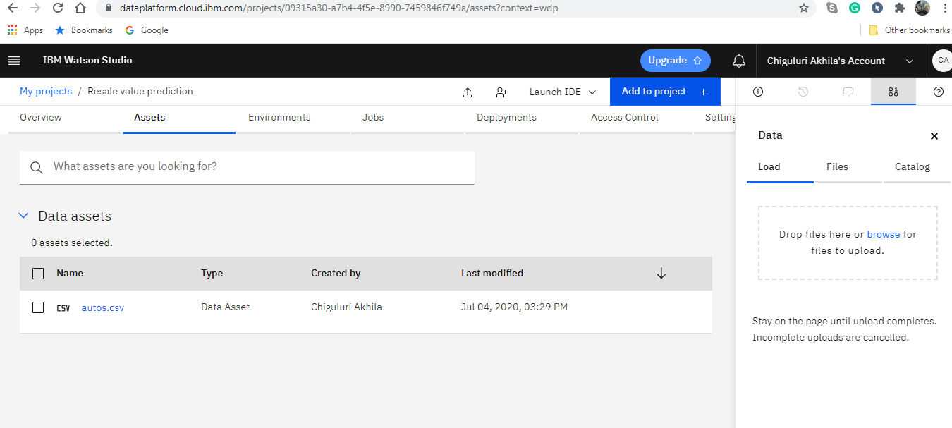

* 1. Then we need to choose the machine learning algorithm that best fits for the predictive analysis.
  2. Next we need to deploy the model.

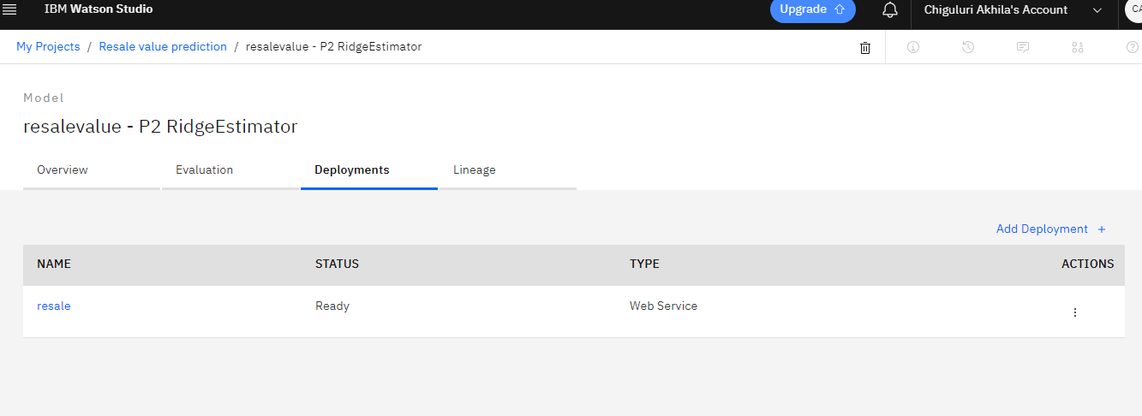

* 1. Then we test the model against various values from the dataset.

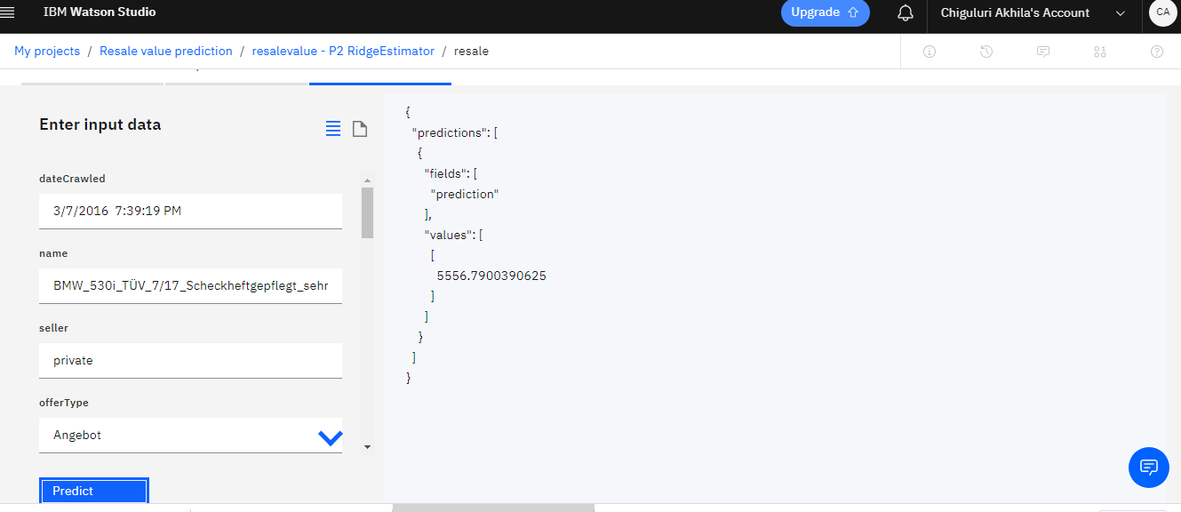

* 1. After this we need to create a service credential and also the cloud foundry app.

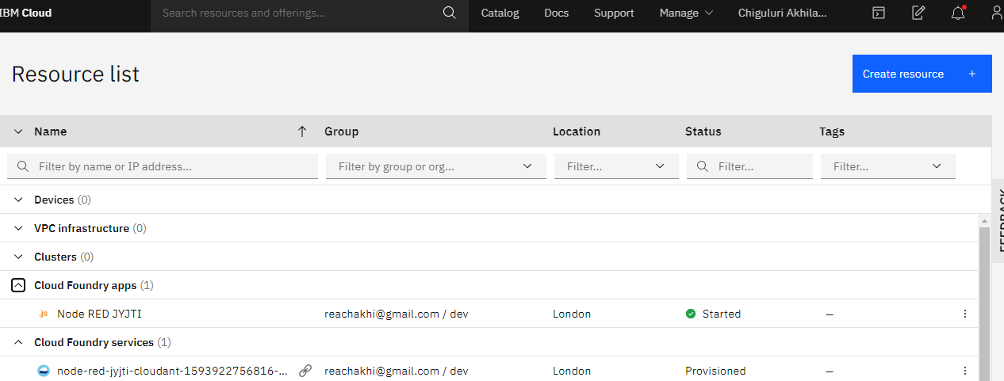

* 1. Next we make a node-RED flow.

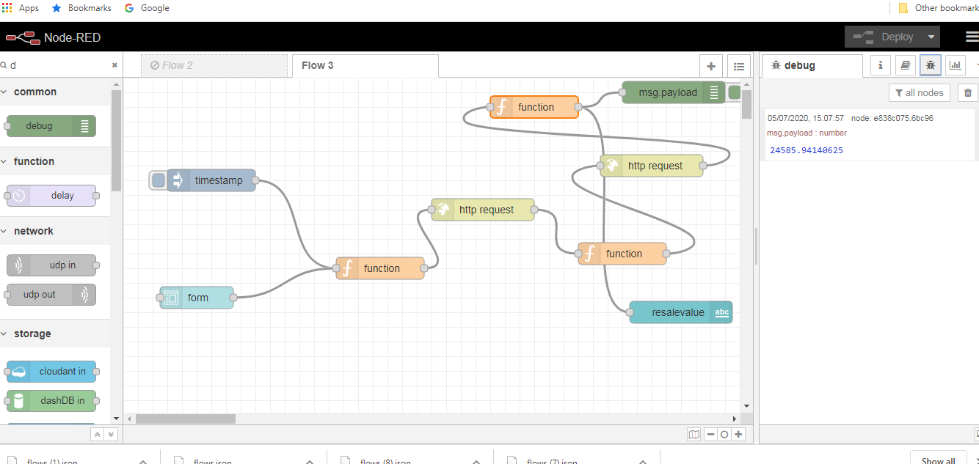

* 1. Once the model is deployed it can be seen on the user interface.

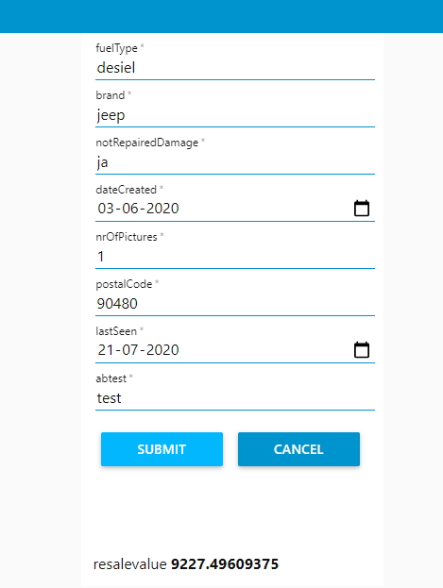

**5. FLOWCHART:**



**6. RESULT:**

The predictive analysis machine learning model predicts the salvage value of the car based on the factors like purchased year, number of kilometres travelled, repairs,mileage,gear type, brand,etc.



**7. ADVANTAGES AND DISADVANTAGES:**

**ADVANTAGES:**

This model helps in predicting the cost of the car based on the information and various factors which benefits both the buyer and seller by avoiding conflicts. This model makes the work easier for the buyer and seller as there is an increase in the demand of this field.

**DISADVANTAGES:**

The model may not always be accurate and various factors may have different kind of influence on the result.

**8. APPLICATIONS:**

This model predicts the salvage value based on the factors so that both the buyer and seller will be benefited equally and makes the work easier as there is a growth in the resale business due to the present difficulties in the economic conditions.

**9. CONCLUSION:**

It has been a great experience working on this project and also learning a lot of new and interesting things from smartbridge. The mentors were very helpful at every point of the project and I learnt a lot of new information working on this. Coming to my model I can say that the model would be very useful to predict the salvage value easily by making the work of the buyers and sellers easier. The bootcamp was very informative and helped me a lot to experiment and explore.

**10. FUTURE SCOPE:**

This model can be future improvised by adding some more deciding factors and also can be made more efficient by improving the performance and accuracy.

**11. BIBLIOGRAPHY:**

* Kaggle for downloading the dataset.
* Smartbridge bootcamp to learn how to work on IBM Watson studio.